C:\Users\Nevi\Downloads\CSA05_CO1_Short Answer Niveditha_ (1).docxSIMATS ENGINEERING (SAVEETHA SCHOOL OF ENGINEERING)
Department of Computer Science and Engineering
CO2 ASSESSMENT TOOL 1 – Scenario-Based Requirement Analysis

Course Code: | CSA10 / CSA1063 | Course Title: | Software Engineering
CO Assessed: | CO2 | Assessment: | Assessment Tool 2 – Scenario-Based Requirement Analysis
Weightage: | 20% | Total Marks: | 25
CO2 Statement: | Perform detailed requirements analysis, design scalable architectures, and prioritize features with a focus on cross-disciplinary skills
Student Name: |  | Reg. No.:
Date: |  | Duration: | 60 minutes

Code of Conduct
I S.NIVEDITHA(192421440L) (Name / Reg No) certify that this submission is my original work and that I have adhered to the guidelines specified for this assessment. I understand that any violation of academic integrity rules will result in disciplinary action.
Signature of the Student: NIVEDITHA
Annexure A – Scenario-Based Requirement Analysis
Instructions to Students:
Each student will be assigned an individual software project problem statement. Analyze the given scenario and prepare a complete Software Requirement Analysis document by following the steps below.
- The Student Skill Assessment and Competency Tracking Platform is a software application designed to help educational institutions assess and monitor students' skills effectively.
- It allows teachers to conduct assessments, evaluate student performance, and maintain competency records digitally.
- Students can view their marks, track their progress, and identify areas for improvement.
- The system reduces manual work, improves accuracy, and provides a centralized platform for managing assessment data.

Question
Based on the assigned problem statement, perform a Scenario-Based Requirement Analysis and prepare a Software Requirement Specification (SRS) document. Your analysis should include the following:

- Study and Analyze the Scenario
Carefully understand the given problem statement.
- The Student Skill Assessment and Competency Tracking Platform is designed to help educational institutions assess, monitor, and improve students' skills using a centralized digital system.
- Instead of maintaining assessment records manually, the platform allows teachers to evaluate students, track competency levels, and generate progress reports efficiently.
- Students can view their performance, identify their strengths and weaknesses, and monitor their improvement over time.
- The system provides a secure and user-friendly environment for managing assessment-related information.

  - Identify the business domain, stakeholders, existing challenges, and system objectives.
- The project belongs to the Education Domain.
- It focuses on assessing students' skills and tracking their competency levels.
- The platform helps educational institutions manage student assessments digitally.
- It improves the teaching and learning process through continuous performance monitoring.
- The system supports schools, colleges, and universities in maintaining accurate academic records.
- Identify Functional and Non-Functional Requirements
  - List all functional requirements required by the proposed system.
- User Registration: The system should allow students, teachers, and administrators to register with valid details.
- Secure Login: Users should be able to log in using a unique username and password.
- Role-Based Access: The system should provide different access levels for students, teachers, and administrators.
- Profile Management: Users should be able to view and update their personal information.
- Course Management: The administrator should be able to add, update, and remove courses and subjects.

  - Identify suitable non-functional requirements such as performance, security, reliability, usability, scalability, maintainability, and availability.
- Performance

  - The system should respond to user requests within 2–3 seconds under normal conditions.
- It should support multiple users accessing the platform simultaneously without affecting performance.
- Reports and assessment results should be generated quickly.
2. Security
- The system should provide secure login using usernames and passwords.
- User data should be protected through encryption and role-based access control.
- Only authorized users should be allowed to access or modify data.
3. Reliability
- The system should provide accurate assessment results and competency records.
- It should operate with minimal downtime and recover quickly from failures.
- Data should remain consistent without duplication or loss.
4. Usability
- The user interface should be simple, attractive, and easy to understand.
- Students, teachers, and administrators should be able to use the system with minimal training.
- The system should provide clear navigation and user-friendly features.
5. Scalability
- The platform should support a growing number of students, teachers, courses, and assessments.
- It should maintain good performance even as the database size increases.
- New features should be added without affecting existing functions.

- Identify Actors and Use Cases
  - Identify all primary and secondary actors interacting with the system.
Primary Actors
- Student – Takes assessments, views marks, and tracks progress.
- Teacher – Creates assessments, evaluates students, and updates marks.
- Administrator – Manages users, courses, and system records.
Secondary Actors
- Parents – View the student's performance and progress reports.
- College Management – Monitors overall performance and analyzes reports.

  - List the major use cases associated with each actor.
1. Student
- Register and Login: Students can create their accounts using valid details and securely log in to access the platform.
- Attend Assessments: Students can participate in online tests, quizzes, assignments, and submit their answers within the given time.
- View Marks and Competency Levels: Students can check their assessment scores, grades, and competency levels after evaluation.
- Track Academic Progress: Students can monitor their overall performance through progress reports and identify areas that need improvement.
- Update Profile and Download Reports: Students can update their personal information and download or print their performance reports whenever required.

2. Teacher
- Login to the System: Teachers can securely log in to access assessment and student management features.
- Create and Manage Assessments: Teachers can create quizzes, assignments, practical tests, and schedule assessments for students.
- Evaluate Students: Teachers can assess student submissions, assign marks, and provide feedback for improvement.
- Update Competency Levels: Teachers can record students' skill levels based on their assessment performance.
- Generate Performance Reports: Teachers can generate individual and class-wise reports to monitor student progress.
3. Administrator
- Manage Users: The administrator can add, update, and remove student, teacher, and parent accounts.
- Manage Courses and Subjects: The administrator can create, edit, and organize courses, subjects, and competency categories.
- Maintain Assessment Records: The administrator can manage assessment data and ensure all records are stored correctly.
- Generate System Reports: The administrator can generate institution-wide reports for academic analysis and decision-making.
- Maintain System Security: The administrator is responsible for database management, backups, and ensuring secure system operation.
4. Parents
- View Student Performance: Parents can access their child's marks, grades, and overall academic performance.
- Monitor Competency Reports: Parents can review their child's skill development and competency levels over time.
- Track Academic Progress: Parents can monitor progress reports and receive updates about assessment results and performance.
5. College Management
- View Institutional Reports: Management can access department-wise and institution-wide academic performance reports.
- Analyze Student Performance: They can analyze competency levels and overall student achievements to identify trends.
- Monitor Academic Progress: Management can track the performance of students across different courses and departments.
- Support Decision Making: Reports generated by the system help management make informed academic and administrative decisions.

  - Draw a Use Case Diagram representing the interactions between actors and the system.
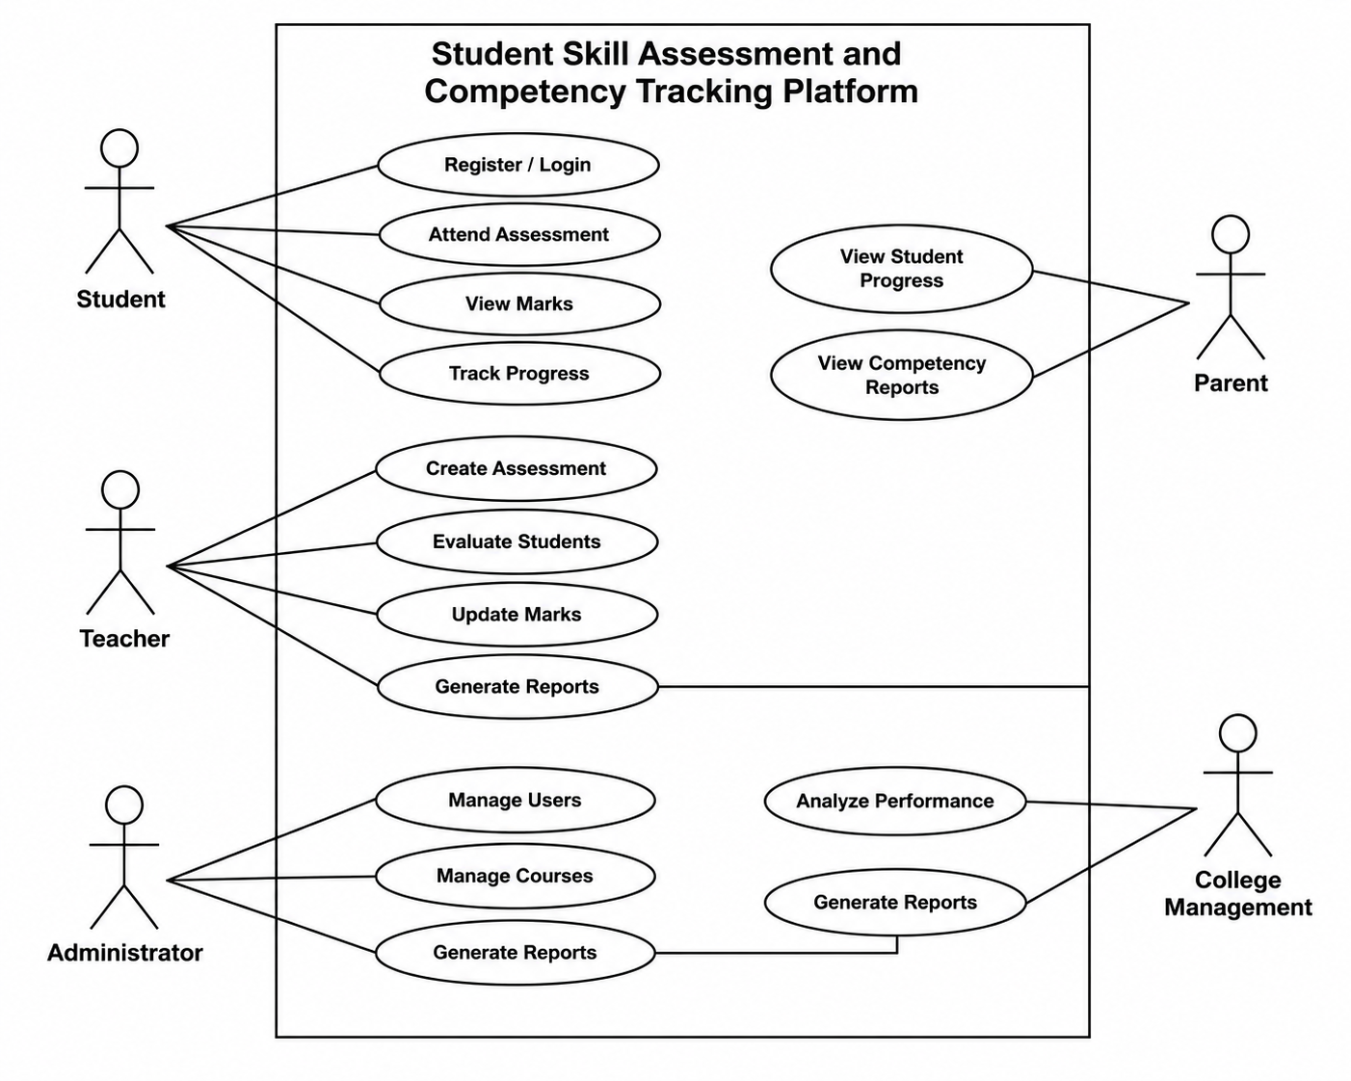

- Prepare the Software Requirement Specification (SRS)
Develop an SRS document containing:
Introduction
- The Student Skill Assessment and Competency Tracking Platform is a software system developed to help educational institutions manage student assessments and monitor competency levels efficiently.
- It provides a centralized platform where students, teachers, administrators, parents, and college management can access assessment-related information according to their roles.
- n many institutions, assessment records are maintained manually, which makes it difficult to track student progress, generate reports, and evaluate skill development accurately.
- This system replaces the manual process with a digital platform that stores assessment data securely and provides quick access to performance records.
- The platform allows teachers to create assessments, evaluate student performance, update competency levels, and generate reports
- Students can attend online assessments, view their marks, track their academic progress, and identify areas for improvement. Administrators can manage users, courses, assessments, and maintain the overall system.
  - Problem Description
- Many educational institutions still use manual methods or basic spreadsheets to manage student assessments and competency records.
- These methods are time-consuming, difficult to maintain, and may lead to errors, data duplication, or loss of important information.
- As the number of students increases, tracking individual skill development and academic progress becomes more challenging.
- Teachers spend significant time recording marks, preparing reports, and monitoring student performance.
- Students often receive only examination scores without detailed information about their strengths, weaknesses, and competency levels.
  - Scope of the System
- The system allows students to register, log in securely, attend online assessments, view marks, check competency levels, track academic progress, download performance reports, and update their personal profiles.
- The system enables teachers to create and schedule assessments, upload questions, evaluate student performance, assign marks, update competency levels, provide feedback, and generate individual as well as class-wise performance reports.
- The administrator can manage student, teacher, and parent accounts, maintain course and subject information, manage assessment records, monitor system activities, and ensure smooth operation of the platform.
- The platform provides parents with access to their child's academic performance, competency reports, and progress updates, helping them stay informed about their child's learning and development.
- The system allows college management to monitor overall student performance, analyze competency reports, generate institutional reports, and make effective academic and administrative decisions.
  - Functional Requirements
- User Registration: The system should allow students, teachers, administrators, and parents to register by providing valid personal and institutional details. Each user should receive a unique account to access the platform.
- Secure Login and Authentication: The system should provide secure login using a username and password. Only authorized users should be able to access the system based on their assigned roles.
- Profile Management: Users should be able to view and update their personal information, change passwords, and manage their profiles whenever required.
- Student Management: The administrator should be able to add, edit, delete, and maintain student records, including academic and personal details.
- Teacher Management: The administrator should be able to manage teacher accounts, assign subjects, and update teacher information.
  - Non-Functional Requirements
- Performance: The system should respond quickly to user requests and display assessment results, reports, and other information within a few seconds.
- Security: The system should protect user data through secure login, password encryption, and role-based access control.
- Reliability: The system should provide accurate assessment results and competency records with minimal errors
- Usability: The system should have a simple, user-friendly interface that is easy to understand and use.
- Scalability: The system should be capable of supporting a growing number of students, teachers, courses, and assessments without affecting performance.
  - Use Case Descriptions

1. Student
- The student can register and log in to the system using valid credentials. After logging in, the student can view available assessments, attend online tests, submit answers, check marks and competency levels, track academic progress through reports, update personal profile details, and download performance reports.

2. Teacher
- The teacher can securely log in to the system to create and manage assessments, upload questions, evaluate student submissions, assign marks and grades, update competency levels, provide feedback to students, and generate individual or class performance reports.

3. Administrator
- The administrator is responsible for managing the overall system. The administrator can create and manage user accounts, add or update courses and subjects, maintain assessment records, generate institution-wide reports, monitor system activities, perform database maintenance, and ensure system security.

4. Parents
- Parents can log in to the system to view their child's academic performance, competency reports, assessment results, and overall progress. They can also receive notifications about important academic updates and student performance.

5. College Management
- College management can access overall academic reports, analyze student competency and performance, monitor department-wise progress, evaluate institutional performance, and use the generated reports to support academic planning and decision-making.
  - Data Requirements
    - Student Data: The system should store student details such as Student ID, Name, Roll Number, Department, Year of Study, Contact Information, and Login Credentials.
    - Teacher Data: The system should maintain teacher information, including Teacher ID, Name, Department, Subject, Contact Details, and Login Credentials.
    - Course and Subject Data: The system should store details of courses, subjects, semesters, and competency categories offered by the institution.
    - Assessment Data: Information related to quizzes, assignments, practical exams, online tests, assessment schedules, total marks, and evaluation criteria should be maintained.
    - Marks and Grades Data: The system should record students' marks, grades, assessment results, and overall academic performance for each subject.

External Interface Requirements
1. User Interface
- The system should provide a simple and user-friendly interface that allows students, teachers, administrators, parents, and college management to access the platform easily. It should include login pages, dashboards, assessment pages, report pages, and profile management screens with easy navigation.
2. Hardware Interface
- The system should work on desktops, laptops, tablets, and smartphones. It should require a stable internet connection and standard hardware devices such as a keyboard, mouse, and printer for report printing when needed.
3. Software Interface
- The platform should be compatible with modern web browsers such as Google Chrome, Microsoft Edge, Mozilla Firefox, and Safari. It should use a Database Management System (DBMS) such as MySQL for storing data and support operating systems like Windows, Linux, Android, and iOS.
4. Communication Interface
The system should use a secure internet connection to exchange data between users and the server. It should support email or SMS notifications for assessment schedules, results, announcements, and other important updates while ensuring secure data transmission.
  - System Features
- User Registration and Login: The system allows students, teachers, administrators, and parents to register and securely log in using their credentials.
- Assessment Management: Teachers can create, schedule, update, and manage online assessments, quizzes, assignments, and practical tests for students.
- Student Performance Evaluation: Teachers can evaluate student submissions, assign marks and grades, provide feedback, and update competency levels based on assessment results.
- Competency Tracking: The system continuously tracks students' skills and competency levels, helping them understand their strengths and identify areas for improvement.
- Progress Monitoring: Students can view their academic progress, assessment history, competency reports, and overall performance through a personalized dashboard.
- Identify Assumptions and Constraints
  - List the assumptions considered while developing the system.
    - All users (students, teachers, administrators, parents, and management) have valid login credentials to access the system.
    - Users have a stable internet connection and a compatible device such as a computer, laptop, tablet, or smartphone.
    - Teachers regularly create assessments, evaluate students, and update marks on time.
    - Students attend assessments honestly and submit their answers within the specified time.
    - The administrator maintains user accounts, courses, and system data properly.
    - The database is available and stores all assessment records securely without data loss.
    - Users have basic knowledge of using a web-based application.
    - The institution provides the required hardware, software, and network infrastructure to operate the system.
  - Identify technical, operational, economic, legal, and time-related constraints affecting the project.
1. Technical Constraints
- The system requires a stable internet connection for smooth operation.
- It depends on compatible hardware, web browsers, and a reliable database server.
- Regular system maintenance and software updates are necessary to ensure proper performance.
- The platform must support secure data storage and backup facilities.
2. Operational Constraints
- Teachers must upload assessments, marks, and competency records on time.
- Students should complete assessments within the specified schedule.
- Administrators are responsible for managing users, courses, and system data efficiently.
- Users should have basic knowledge of using a web-based application.
3. Economic Constraints
- The project should be developed within the available budget.
- Costs for hardware, software, database, hosting, and maintenance should be minimized.
- The institution should allocate sufficient funds for future upgrades and support.
- 4. Legal Constraints
- The system must protect the privacy and confidentiality of student and staff information.
- It should comply with institutional policies and applicable data protection regulations.
- Only authorized users should have access to sensitive academic records.
- User data should not be shared or modified without proper permission.
5. Time-Related Constraints
- The project should be completed within the planned development schedule.
- Testing and deployment should be finished before the start of the academic session.
- Reports, assessment results, and notifications should be generated and delivered on time.
- Validate Requirement Completeness and Consistency
  - Verify whether all stakeholder requirements have been addressed.

    - The requirements of students have been addressed by providing features such as registration, login, online assessments, viewing marks, tracking competency levels, and downloading performance reports.
    - The requirements of teachers have been addressed through assessment creation, student evaluation, marks management, competency tracking, feedback, and report generation.
    - The requirements of the administrator have been addressed by including user management, course management, assessment management, database maintenance, report generation, and system security.
    - The requirements of parents have been addressed by providing access to their child's academic performance, competency reports, and progress updates.
    - The requirements of college management have been addressed through institution-wide reports, performance analysis, competency monitoring, and support for academic decision-making.
  - Check for ambiguity, redundancy, inconsistency, and missing requirements.
1. Ambiguity
- All requirements are written in clear and simple language.
- Each system function is well-defined and easy to understand.
- User roles and responsibilities are clearly specified, reducing confusion.
2. Redundancy
- Duplicate or repeated requirements have been removed.
- Each requirement is listed only once to avoid unnecessary repetition.
- Similar functionalities are grouped under appropriate sections.
3. Inconsistency
- There are no conflicting requirements between different user roles.
- Functional and non-functional requirements support each other.
- All system features are consistent with the project objectives and stakeholder needs.
4. Missing Requirements
- The requirements cover all major stakeholders, including students, teachers, administrators, parents, and college management.
- Security, performance, usability, reliability, data management, and report generation requirements are included.
- Future enhancements such as mobile support and advanced analytics can be added later but are not essential for the current system.
  - Suggest improvements to enhance the quality and completeness of the requirement specification.
    - Provide More Detailed Requirements: Add clear descriptions for each functional and non-functional requirement to avoid confusion during development.
    - Include More Use Cases: Add additional use cases such as password recovery, profile management, notifications, and report downloading to improve system coverage.
    - Improve Security Requirements: Include features such as password encryption, two-factor authentication, secure data storage, and regular backups to enhance system security.
    - Add Error Handling Requirements: Specify how the system should handle invalid logins, network failures, incomplete submissions, and unexpected system errors.
    - Include Performance Metrics: Define measurable requirements such as response time, maximum number of users supported, and report generation time.
Rubrics for Calculation
Criteria | Excellent (4 Marks) | Good (3 Marks) | Satisfactory (2 Marks) | Needs Improvement (1 Mark)
Scenario Understanding and Problem Analysis | Demonstrates thorough understanding of the scenario, stakeholders, objectives, and business context with clear analysis. | Demonstrates good understanding with minor omissions. | Basic understanding with limited analysis. | Poor understanding; major aspects missing or incorrect.
Functional and Non-Functional Requirement Identification | Clearly identifies comprehensive, accurate, and well-classified functional and non-functional requirements. | Identifies most requirements with minor classification errors. | Identifies only basic requirements; several omissions. | Requirements are incomplete, inaccurate, or poorly classified.
Actor Identification and Use Case Modeling | Correctly identifies all relevant actors and use cases; use case diagram is complete, accurate, and follows UML standards. | Most actors and use cases identified; diagram has minor errors. | Limited actors/use cases identified; diagram partially correct. | Actors/use cases missing or incorrect; diagram absent or inaccurate.
Software Requirement Specification (SRS) Documentation | SRS is well-structured, complete, professionally organized, and includes all required sections. | SRS is organized with minor missing sections or formatting issues. | SRS includes only essential sections with limited detail. | SRS is incomplete, poorly organized, or lacks essential components.
Assumptions, Constraints, and Requirement Validation | Clearly identifies realistic assumptions and constraints; validates requirements for completeness, consistency, and ambiguity with appropriate justification. | Identifies most assumptions and constraints; validation is adequate. | Limited assumptions/constraints; validation is superficial. | Assumptions, constraints, and validation are missing or incorrect.

Criteria | Mark
Scenario Understanding and Problem Analysis | /5
Functional and Non-Functional Requirement Identification | /5
Actor Identification and Use Case Modeling | /5
Software Requirement Specification (SRS) Documentation | /5
Assumptions, Constraints, and Requirement Validation | /5
TOTAL | /5

